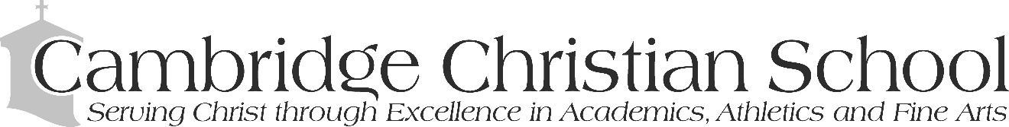

6101 N. Habana Ave. • Tampa, FL 33614 • 813 872-6744 • Fax 813 872-6013

POSITION DESCRIPTION

Title: US Instructor
Reports to: US Principal and US AP
Work Year: 10 months

Position Focus: An US Instructor will pursue and support the vison, mission, and core values of Cambridge Christian School. An US Instructor will work with the US Principal, US AP, and Department Head, and teachers within their department to partner with parents in the training of all high school students as Kingdom Educators.

Spiritual:

- Seek to role model in attitude, speech, and action a consistent daily walk with Jesus Christ
- Motivate others to accept God’s gift of salvation and grow in their faith
- Follow the Matthew 18 principle in dealing with students, parents, staff an administration
- Lead others to a realization of their worth in Christ and cultivate their growth in Christ-like character
- Subscribe to and promote the statement of faith

INSTRUCTIONAL RESPONSIBILITIES:

General
- Assist and monitor any school improvement plans pertaining to their department.
- Attend Open Houses, Parent Night, and Graduation.
- Proctor mid-term and final exams as requested by admin.
- Comply with the discipline procedures as outlined in handbook.
- Comply with the procedures as outlined in the employee handbook; teacher dress, request for time off, no social media interaction with students, sexual ethics, etc.
- Enter daily attendance for every period.
- Establish office hours for the department and communicate with students/families.
- Monitor departmental compliance with all NILD and academic accommodation policies as outlined by Guidance and NILD therapist, to include tracking of extra time for students eligible.
- Participate in J-Term as a lead or support to any of our experimental learning experiences/trips.

Instructional Leadership
- Enter homework on a weekly basis, by Friday or no later than Monday of each week.
- Enter grades on a weekly basis to Ren Web and complete all grades prior to end of each quarter.
- Establish grading distribution/weights as directed by department head and monitor on a weekly basis.
- Participate and enter upcoming test and long-term projects into the US test/project calendar.
- Uphold and comply with department philosophy for homework, missing/make-up work, rigor, and project management.
- Create a course syllabus prior to the start of the school year and seek approval of department head. All information on syllabus should align with all handbook policies.
- Send a communication to parents within the first weeks of school. Maintain open communications with parents throughout the year; course highlights, upcoming projects, trip, student opportunities, teacher office hours, etc.
- Communicate with parents and student in regards to failing grades and student performance immediately, and document all communications.
- Provide Biblical integration in their prospective subjects.

Curricular Leadership
- Create/Update curricular maps for each course through Rubicon Atlas.
- Create/Update lesson plans on a weekly basis. All lesson plans are to be posted in Rubicon Atlas within each corresponding curricular map. Lesson plans will be monitored by department heads.
- Create exams and exam reviews and submit to department head prior to established deadlines.
- Assist the department head through the curricular adaptation process of new curriculum.
- Assist the department head with the coordination of curricular resources for their department; preview new curriculum, track and order curricular resources throughout the year, and oversee all student access to curriculum.
- Inventory any physical curricular resources and distribute accordingly.

Professional Development
- Attend weekly PD offerings provided by CCS.
- Keep abreast of current educational practices and attend professional conferences/workshops as made available by department head and Principals.
- Enter PD to CCSI.
- Monitor and keep abreast of their teacher certification status and progress.
- Establish a practice to reflect and create a plan for obtaining summer PD.

School Culture
- Participate in teacher devotions (optional but they are a blessing!).
- Lead an advisory group and assist with class events as assigned by Principals.
- Attend chapel services and sit with prospective advisory group.
- Attend divisional, departmental, and all pre/post planning meetings as directed by admin.
- Demonstrate support for the school by attending school events and US events such as fine art events, sporting events, Baccalaureate, US academic events, and marketing/fundraising events.
- Maintain a school-wide climate of high expectations, growth mindset, and cooperation.

